Git Concepts and Architecture :

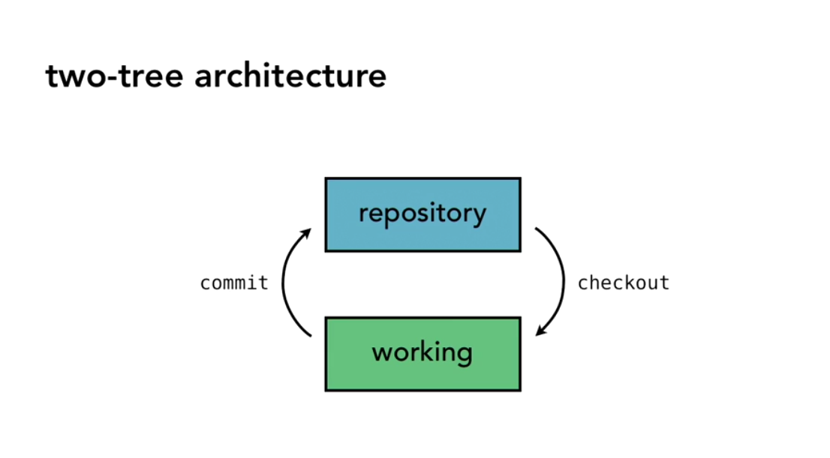

Figure 1 Two-tree Architecture

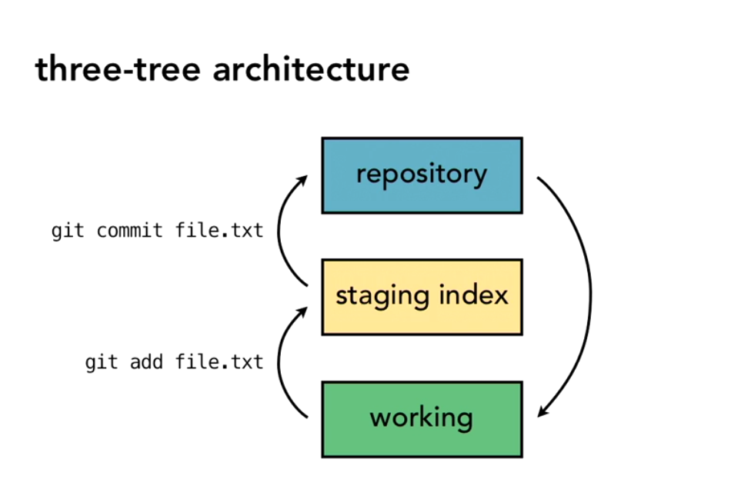

Figure 2 Three-tree Architecture

Staging index: committing only few files into Repository. (Stage them for the commit

**The Git Workflow:**

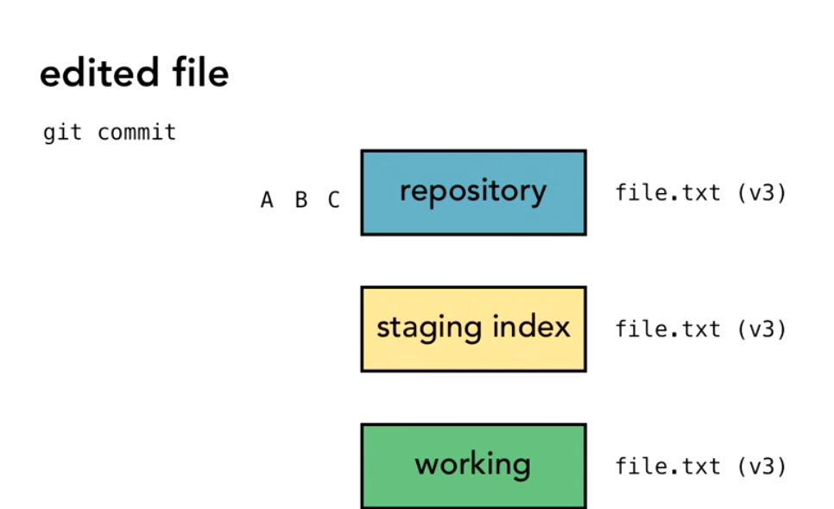

git add file1.txt (version1) working Directory 🡪 Staging Index

git commit (v1) Staging index 🡪 Repository

A , B , C 🡪 change sets

**Referring to commits** ( using hash values(SHA-1) )

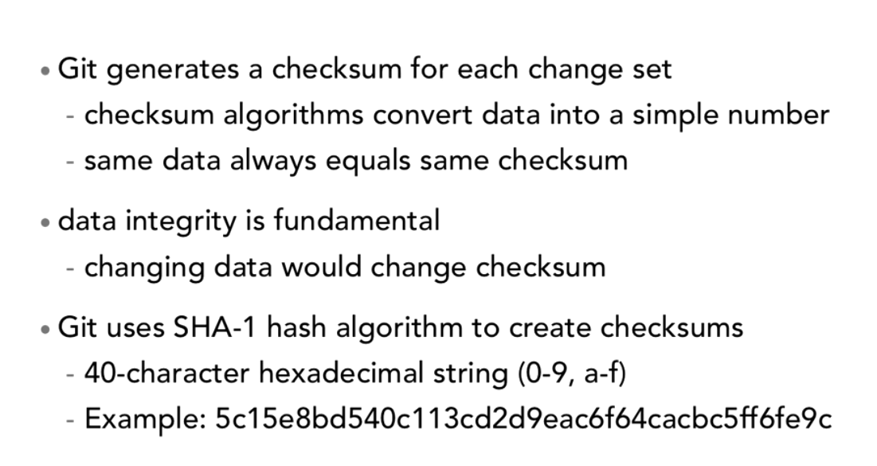

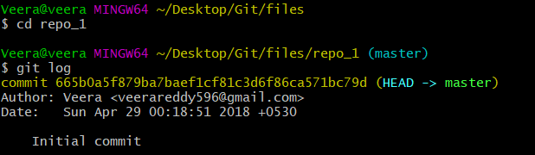

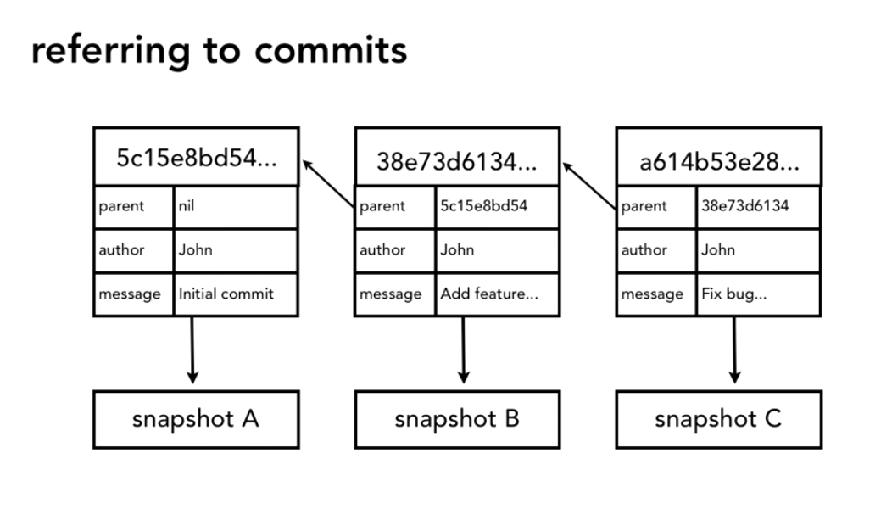

**HEAD Pointer :**

